**Interactive Website setup locally on your VM (Wordpress)**

* Visit <https://app.vagrantup.com/boxes/search> and download a vagrant file (Create a folder in a directory, you can name it “vagrant-vms”)
* Open the Git CLI and type----- cd /c/vagrant-vms
* mkdir (Name of the project) ……. This is to create a directory
* cd /c/vagrant-vms/(Name of the project directory created)
* vagrant init ubuntu/trusty64 (the box name from the cloud)
* Provision your vagrantfile (upgrade,update and install apache or httpd, start apache or httpd)
* vagrant up
* vagrant ssh
* sudo –i
* For completion steps: <https://ubuntu.com/tutorials/install-and-configure-wordpress#2-install-dependencies>
* When you reach step 4 in the guide: <https://ubuntu.com/tutorials/install-and-configure-wordpress#2-install-dependencies>

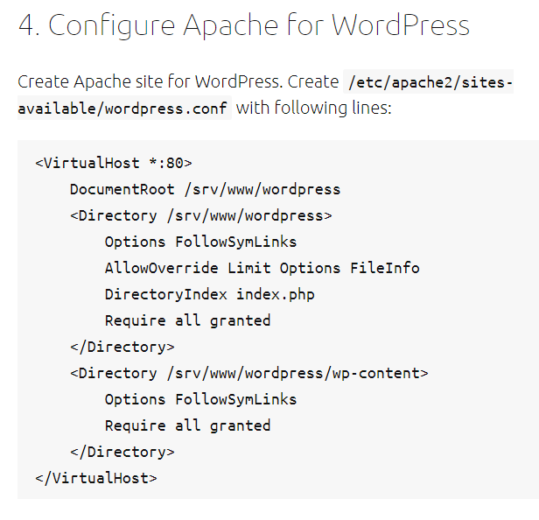

vim /etc/apache2/sites-available/wordpress.conf (copy the code virtualhost and paste in the editor)

* Follow the remaining steps in step4
* For step 5 use the pics below as a guide

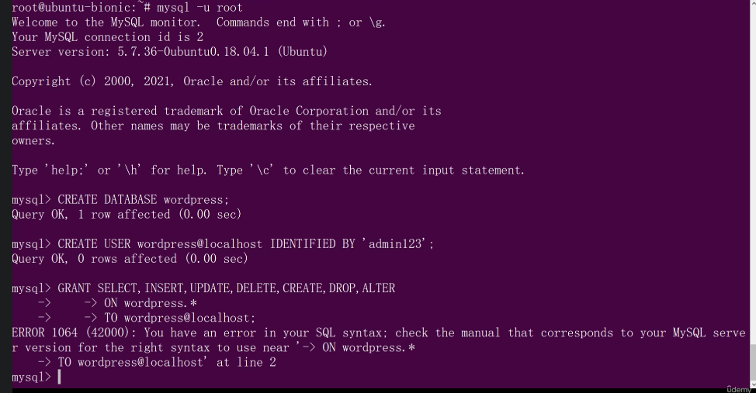

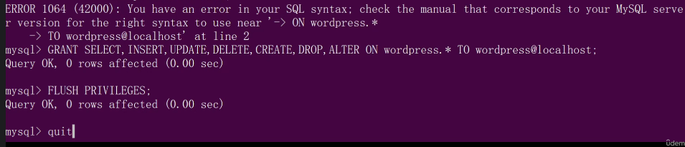

* For step 6 use the pics below as a guide

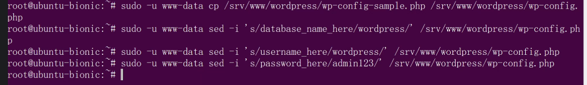

**Open the configuration file, I use vim instead of nano**

vim /srv/www/wordpress/wp-config.php (delete the lines as instructed and replace with the lines in the link given)

<https://api.wordpress.org/secret-key/1.1/salt/>.

* For step 7

Get your vm IP from ipconfig and use it in your browser instead of the localhost

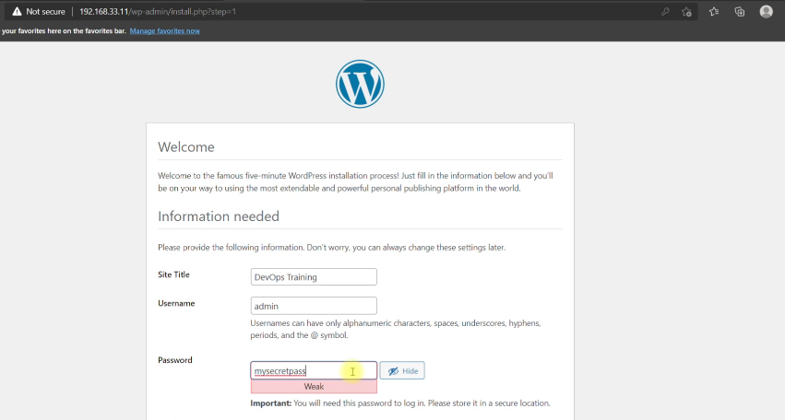

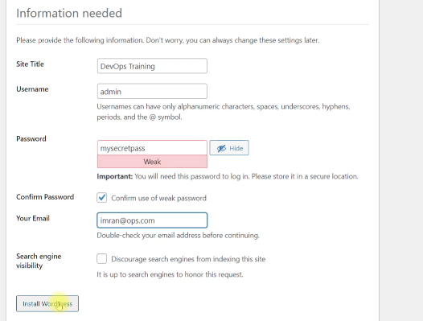

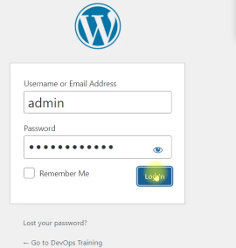

Login with the credentials you used not the database credentials and configure your wordpress site… Goodluck!!!